How to program in C under PROSE
~

If you want to program in C under PROSE is necessary, first of all, download the development environment from Zilog's website. Registration is required but is free and the package to download is called: ZDS II eZ80Acclaim!

After installation, start the development environment and you will come to this screen:

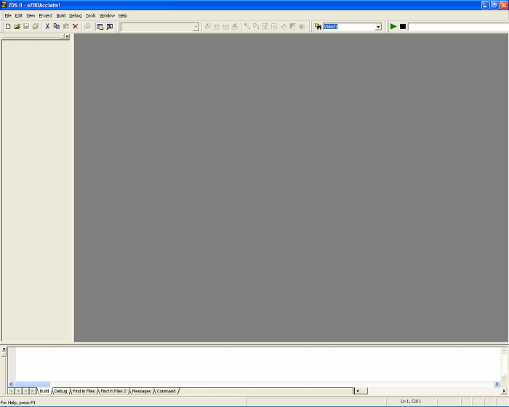
We then create a small sample program. Let's go to File->New Project and this window will appear:

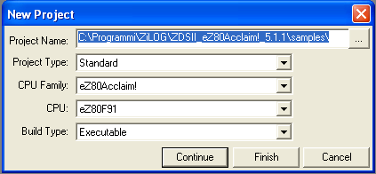
Select the folder to save the project and then set the various parameters:

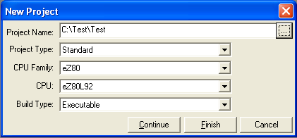
So Project Type = Standard, CPU Family = eZ80, CPU = eZ80L92 and Build Type = Executable, then press the Continue button. A window will appear for setting the build options. Here you HAVE to uncheck “Standard C Startup Module”.

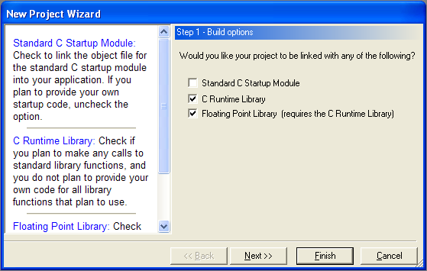
Then click on Next button and the program asks you to select the Target and Debug Tool, you select “eZ80DevPlatform_L92_RAM.

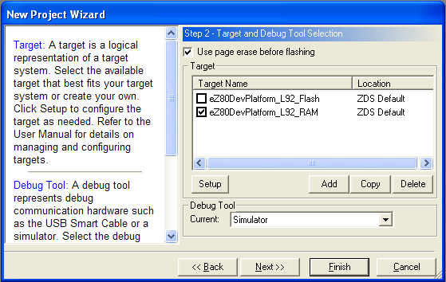
Then click on Next button. Now this part is important, you need to set the memory of our system. The best configuration is: Link Configuration = ALL RAM, ROM = 10000-FFFFF and RAM = 10000-FFFFF.
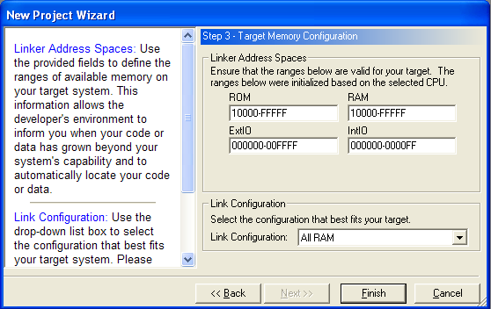
Now press “Finish” to finish the first phase configuration.
Go to File and click “New File”, an empty editing window will appear. Go to File and click Save and rename the file “main.c”. Go “Standard Project Files”, right click and select “Add files ti project” and select main.c. Now save the project.

Attached to this document are a header file called “PROSE_Header.h” that contains macros to interface with PROSE. Do not need to add it to your project if you copied it in the same folder of the main.c, which I suppose for this manual.

Here is the source of a minimal C program for PROSE:
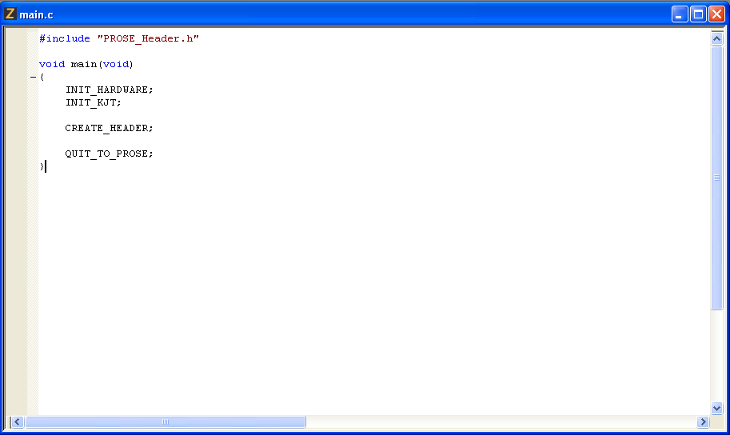
As you can see, a fixed structure is required to generate a correct executable. First of all, the main must ALWAYS be the first function and then the first lines should be INIT_HARDWARE, INIT_KJT and CREATE_HEADER; your code goes between CREATE_HEADER and QUIT_TO_PROSE. Another important thing, in the main you never have to specify local variables in other functions or procedures you can use whatever you want.
Before completing this brief example, you have to configure some options of the project, so go on Project and click on Settings, a series of images you will see how to do:

General:
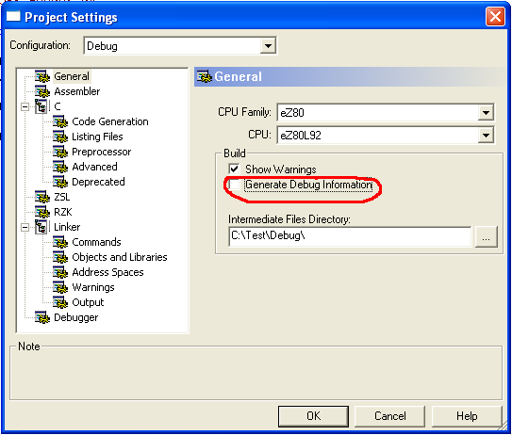
Advanced:
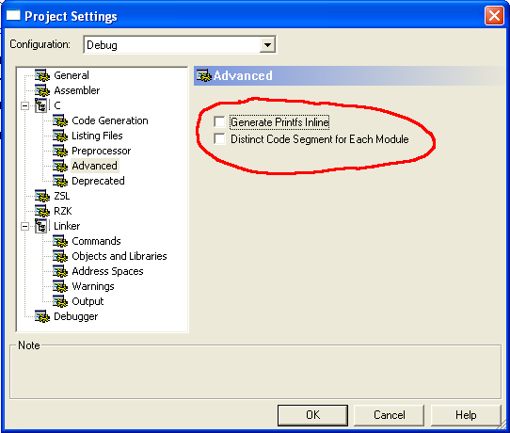

Commands:
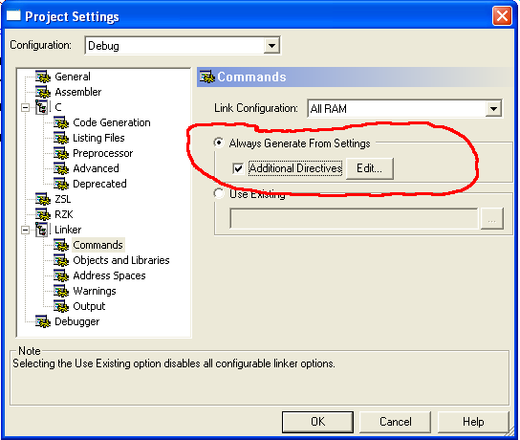
Then you must specify the parameters for the heap, otherwise you can NOT use malloc, realloc ...
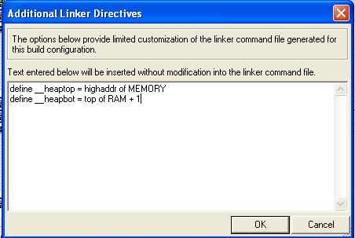
in the text box you must enter: define __heaptop = highaddr of MEMORY and define __heapbot = top of RAM + 1. Now you can use dinamic memory allocation.

Objects and libraries:
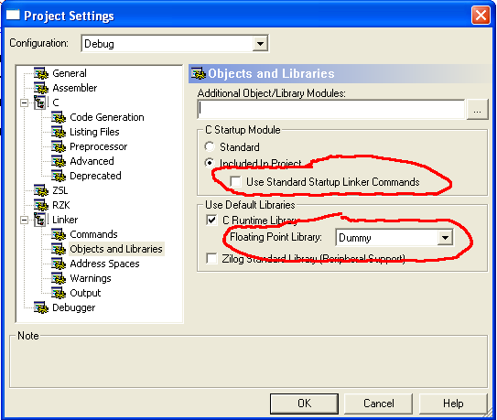
Uncheck “Use standard Startup Linker Commands” and set the Floating Point Library as Dummy. Now click on OK and the sample projects will be compiled.

Now let's see how to place code and data to create a simple application. Suppose we want to create a function that prints a text on the screen, type ShowMessage(“My Text”);

First, we define it first the main:
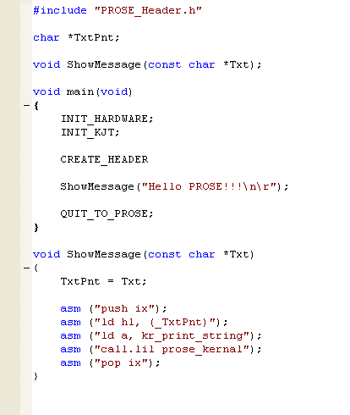
Before you proceed, you must know that the development environment does not allow to pass local variables to inline assembly. So first we define a pointer that will host the local parameter of our function (char *TxtPnt).

Then we pre-declare our function and then defined it after the main.

The function ShowMessage executes these instructions :

1) Copy local parameter Txt in global pointer TxtPnt.

2) Before any calls to the Prose's kernal need to save the IX register.
3) Load in HL the value on pointer TxtPnt. Global variables in the source you wish to pass at the inline assembler are renamed by adding the character "_" before the name defined in the C source.
4) Set a to kr_print_string value and...

5) Call the kernel
6) Restore IX register.

You can also save the value of a register in a C global variable. Suppose that, after a call to the kernal, i want to save the value of the register DE in a global variable. You can do this:

int MyRegValue;

....
....
....

asm (“ld (_MyRegValue), DE);

Remember to always add the character "_" before the name of the variable and specify the variable in parentheses otherwise overwrite the address of a variable.

Of course, you have to use the program developed by Phil to convert the file from hex format to ezp.

This is all, always remember that the main must be the first call and can not have local variables. All functions / procedures should be inserted after the main. Before a call to the kernal, save IX register and after restore it.

Enzo Antonio Calogiuri.

